Starting a Social Media Calendar
Last Updated / Reviewed: April 1st, 2020
Execution Time: N/A


Goal: Creating a social media calendar to help you plan and track your business’ social media activity.

Ideal Outcome: You will never again ask any of the following questions:
- Hey guys, what goes on Facebook today?
- Where do we post this?
- Guys, does anyone remember where we posted that super-funny GIF about our new product?
- Why are we posting only on Facebook?
- Do we even have any other social media accounts?
- Was this approved?
- Who approved this?
- Why is there a monkey eating a banana posted on our LinkedIn?

Pre-requisites or requirements: Just social media accounts and access to Google Sheets. Patience and diligence are quite great to have too :)

Why this is important: All digital marketing efforts should be accounted for. They should be planned, they should be numbered, they should all be aligned with your brand’s goals. A social media calendar will help you plan and manage what is very frequently the single most chaotic type of digital marketing effort.

Where this is done: In Google Sheets, mostly.

When this is done: When you decide to run your social media marketing through a calendar before posting. You only need to create the calendar once - but our advice is to make a new copy of it every week (otherwise, it will most likely get too crowded - especially if you are posting daily on more than one social media channel).

Once you have your calendar set up, you simply need to update it as you go (which shouldn’t take more than 5-10 minutes/day if you are posting daily social media updates, provided that you already have the content you want to post).

Who does this: You, your Social Media Manager, or Community Manager.

Environment setup

- Go to the Social Media Calendar Template.
- Make a copy of the template to use from hereon.

Adjust the template to your needs
Not all businesses are created alike - so it is only natural they won’t all post the same type of content, nor will they post on the same social media channels. The template we created can and should be adjusted according to your particular needs.

More specifically, the drop-down cells in the template we have provided above can be edited so that they are fully aligned with your business and what it does on social media.

You can change these drop-down options by following these steps:

- Select the range of cells you want to edit.
- Go to Data → Data Validation.
- Add/ Remove categories as you find necessary.



Fill in the template
Most of the columns in the template are quite straight-forward and easy to fill in - but, for the purpose of this SOP, we will take them one by one and describe what should go in each of them:
- Publish Date. Self-explanatory, the date at which you want to publish a particular social media update.
- Content Type. For the purpose of this example, we added the following options:
- “Course” (for posts connected to courses)
- “Marketing Campaign” (for special offers you may have at a particular point)
- “Evergreen” (the kind of on-going content that can get promoted over and over again)
- “Right-Time” (the type of content that arises as an opportunity during a holiday, during a special event, etc.).
- Topic/ Title. Add here a general topic for the post, or even a specific title (if you have one).
- Content/ Details. What is the content about, and what is its purpose? Add this kind of detail in this cell.
- Social Network. Again, this is a drop-down option. For the purpose of this example, we added Facebook, Twitter, Instagram, YouTube, and Pinterest. As mentioned before, you can add more or you can remove from these options if they are not suitable for your social media strategy.


- Post Type. This section is very important because it dictates how the post and copy will look. For the purpose of our example, we included the following options:
- “Normal Post” (just text and a picture or two, for instance)
- “Link Post” (text and a link to an article)
- “Chained Post” (specifically for Twitter, where you can thread of tweets)
- “Carousel Post” (when you want to showcase multiple products and you use the “Carousel” feature, allowing users to swipe through multiple pictures).
- Content Type. Again, this is very important because it might dictate the tone, style, and length of the copy itself. Our example includes these options:
- “Photo”
- “Graphic”
- “GIF”
- “Video”
- “UGC” (User-generated content)
- No asset (e.g. when you just post text, without any kind of asset associated with it).
- Copy. Enter the actual copy you will post.
- Asset. Copy and paste the asset you will share with the post. If it’s a picture, upload it into the spreadsheet and minimize it to fit the cell.

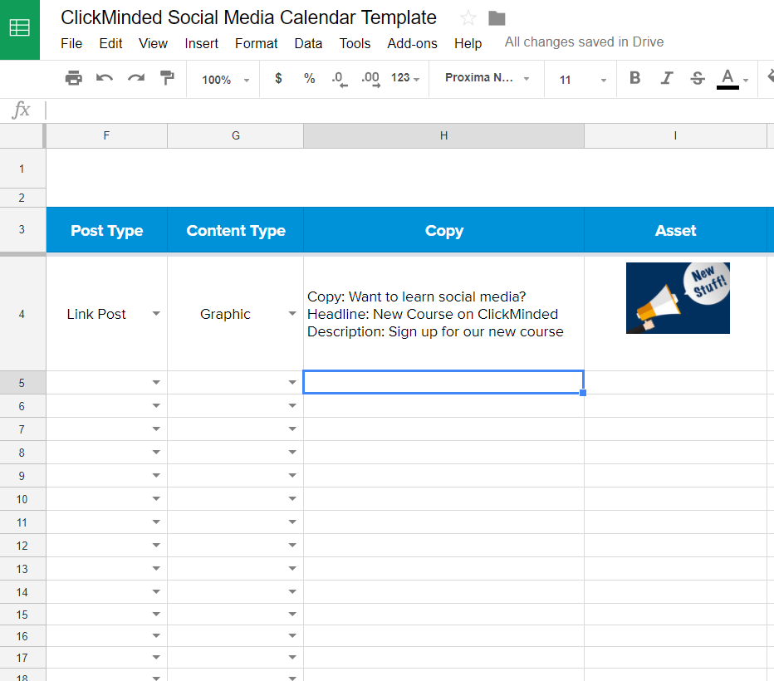

- Link. Add the link you will use in the post, if applicable.
- Shortened Tracked Link. If you shorten your links and track them (with a service like bit.ly), add them here.
- Publishing Time. Self-explanatory. You should add this for further reference, to see what time your visitors are more active.
- Approval 1 and Approval 2. If your post needs to be approved before it goes live, keep these columns (or just one of them if it only needs one approval).
- If you need both approval columns, you can set up a system to let everyone know they need to approve a post. For instance, you could tag the person in charge of giving the first approval, and once they do it, they could tag the person in charge of giving the second approval. You can easily tag someone by adding a comment to the cell and entering their email with a “+” sign before it (e.g. “+CEO@asiteaboutemojis.com”).
- Live Link. Add here the live link of each post. Doing this will help you organize better, knowing exactly where each post was published and when.

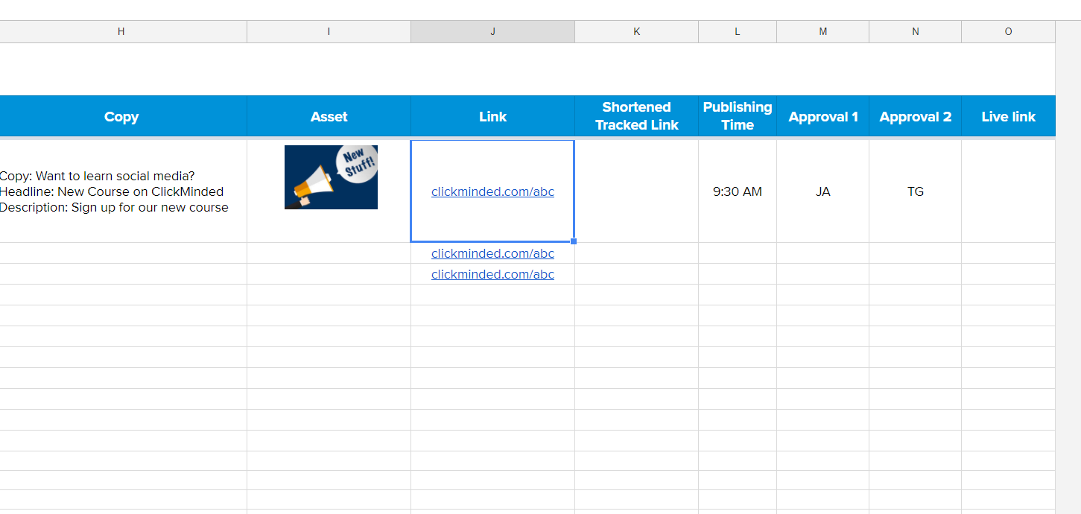

That’s it! As you can see, starting a social media calendar is not difficult at all - the harder part will be to stick to this calendar and continue to fill it in on a weekly basis. We know you can do it, though! There are so many benefits to following a clear calendar!

